K L UNIVERSITY
FRESHMAN ENGINEERING DEPARTMENT
A Project Based Lab Report
On
<TITLE>

SUBMITTED BY:
I.D NUMBER NAME
<IDNO> <NAME>
<IDNO> <NAME>
<IDNO> <NAME>
<IDNO> <NAME>

UNDER THE ESTEEMED GUIDANCE OF
<FULL NAME>
<DESIGNATION>



KL UNIVERSITY
Green fields, Vaddeswaram – 522 502
Guntur Dt., AP, India.

DEPARTMENT OF BASIC ENGINEERING SCIENCES



CERTIFICATE

This is to certify that the project based laboratory report entitled “<TITLE>” submitted by Mr./Ms. <name> bearing Regd. No. <REGD.NO> to the Department of Basic Engineering Sciences, KL University in partial fulfillment of the requirements for the completion of a project based Laboratory in ”DATA STRUCTURES-23SC1202” course in I B Tech II Semester, is a bonafide record of the work carried out by him/her under my supervision during the academic year 2023– 2024.

PROJECT SUPERVISOR HEAD OF THE DEPARTMENT

< GUIDE NAME> Dr. D.HARITHA

ACKNOWLEDGEMENTS

It is great pleasure for me to express my gratitude to our honorable President Sri. Koneru Satyanarayana, for giving the opportunity and platform with facilities in accomplishing the project based laboratory report.
I express my sincere gratitude to our Director, Dr. A. Jagadeesh, for his leadership in fostering our academic growth.
I express my sincere gratitude to our Principal, Dr. V. Krishna Reddy, for his leadership and constant motivation in the successful completion of our academic semester.
I consider it my privilege to express deep gratitude to our pioneer, Dr. D. Haritha, HOD-BES-I, for providing us with efficient faculty and facilities that help turn our ideas into reality.
I express my sincere thanks to our project supervisor <name> for his/her novel association of ideas, encouragement, appreciation and intellectual zeal which motivated us to venture this project successfully.
Finally, it is pleased to acknowledge the indebtedness to all those who devoted themselves directly or indirectly to make this project report success.

Name: <NAME>
Regd . No: <IDNO>

ABSTRACT

INDEX

S.NO TITLE PAGE NO
- Introduction <pageno>
- Aim of the Project <pageno>
2.1 Advantages & Disadvantages
2.2 Future Implementation
- Software & Hardware Details <pageno>
- Data Flow Diagram <pageno>

- Implementation <pageno>

- Algorithm for each module <pageno>
- Integration and System Testing <pageno>

- Conclusion <pageno>

INTRODUCTION

AIM

Advantages:-
Disadvantages:-
Future enhancements:-

SYSTEM REQUIREMENTS

- SOFTWARE REQUIREMENTS:
The major software requirements of the project are as follows:
Language : Dev-C++
Operating system: Windows 11.

- HARDWARE REQUIREMENTS:
The hardware requirements that map towards the software are as follows:
RAM : 4GB
Processor : Intel core i3

DATA FLOW DIAGRAM

ALGORITHM

IMPLEMENTATION

INTEGRATION AND SYSTEM TESTING
OUTPUTS
Screen Shots:
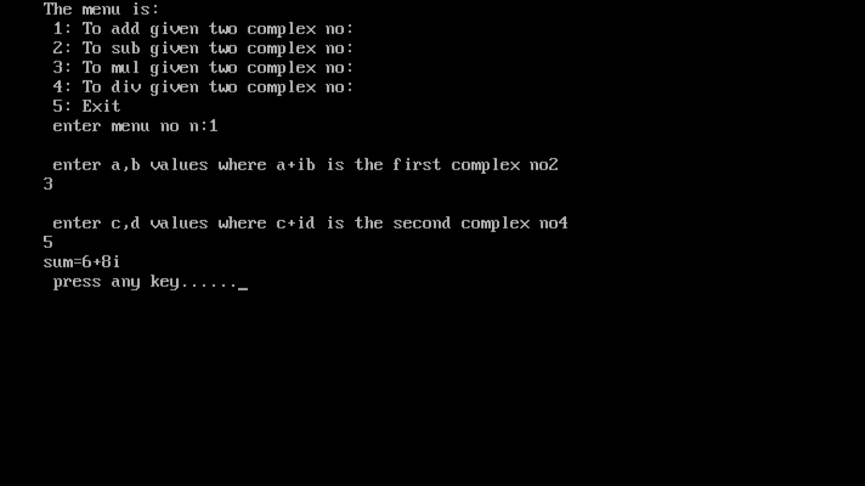
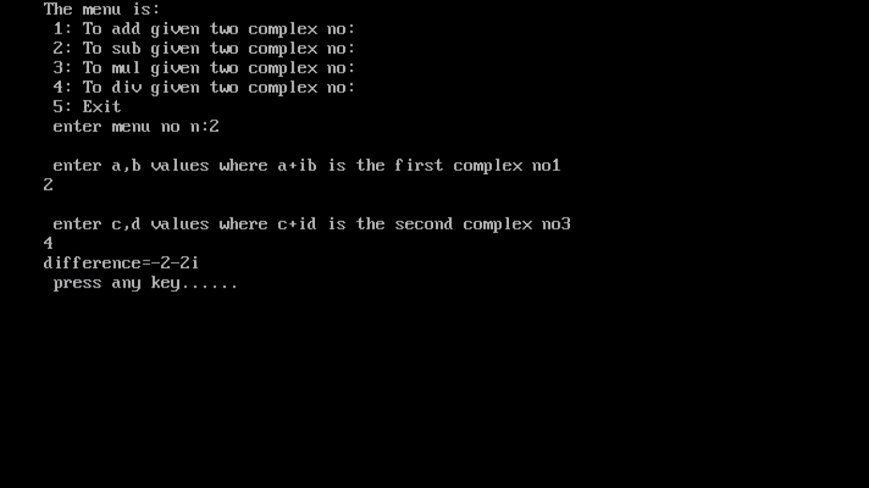

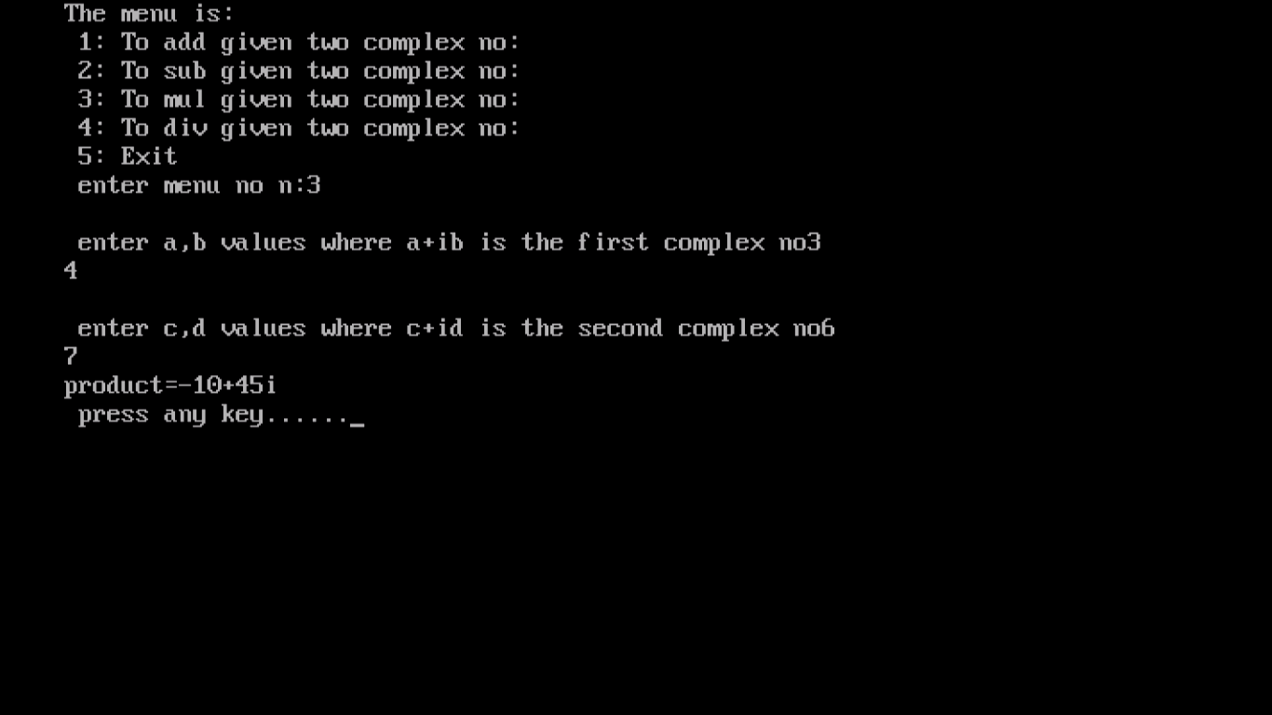
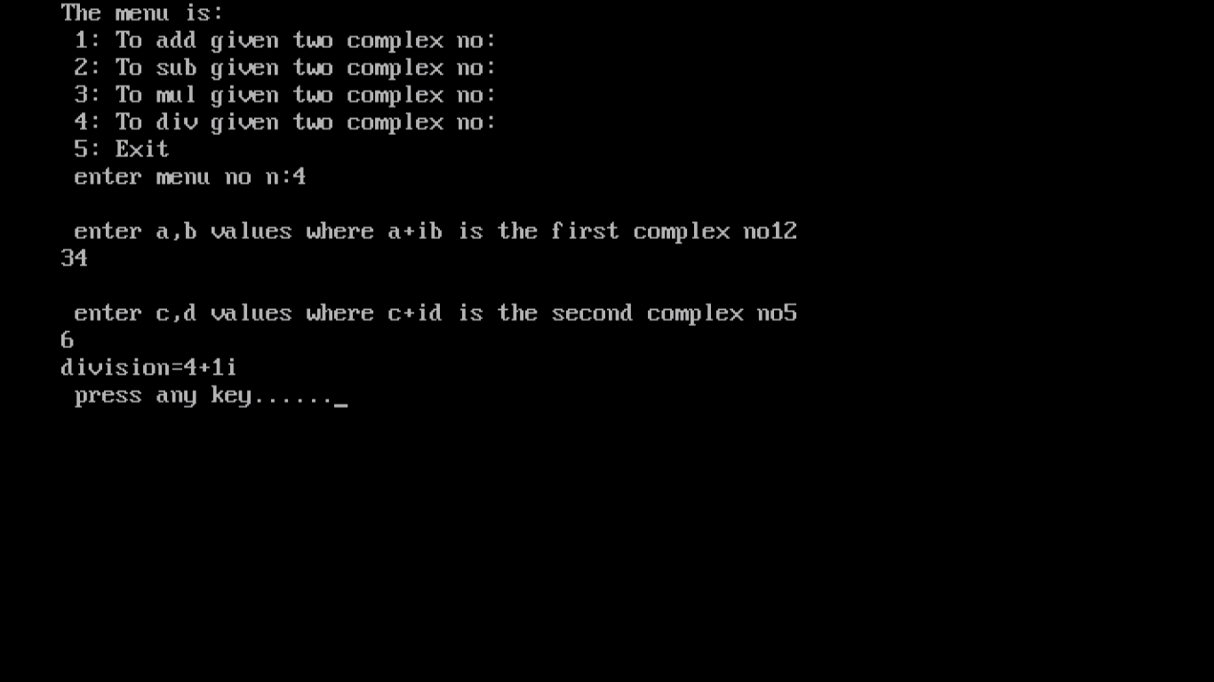

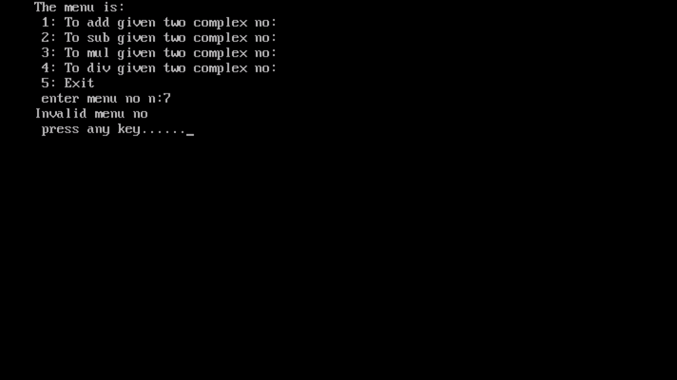

CONCLUSION

